**Koding salah**

Hakim_delete.php



Urusetia_senarai.php



Hakim_borang2.php

Urusetia_menu.php

Urusetia_insert

Penilaian_insert

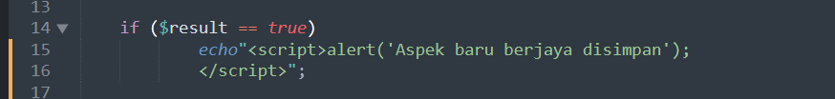

Penilaian_update



Peserta_delete

Penilaian_delete

Urusetia_update

Peserta_update

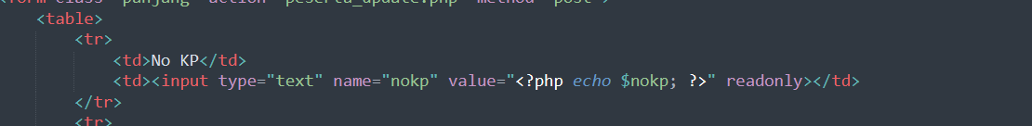



URUSETIA_INSERT

Urusetia_delete

Hakim_update

Hakim_delete

Menu

Peserta_markah- ;

Signup-masukkan koding baru

Tmbh -option

Tmbh – button kembali

Hakim_borang2- tmbh koding

Hakim_borang= tukar type kpd number



Sign_up= tukar reset

Peserta_insert- tukar koding

**Adjust saiz gmbr**

Home.php



Login.php

Button.css

Login.php

Laporan_cetak



Datapeserta.txt

-tidak masukkan idurusetia

import

-buang trim

Tmbh -if

Tutup if - }

Button.css- tambah kembali, tambah gambar back.png

Peserta_carian2 – tambah button cetak

**Perlu lukis gmbr**

Tajuk1.png



Tajuk2.png



Tajuk3.png

Tajuk4.png

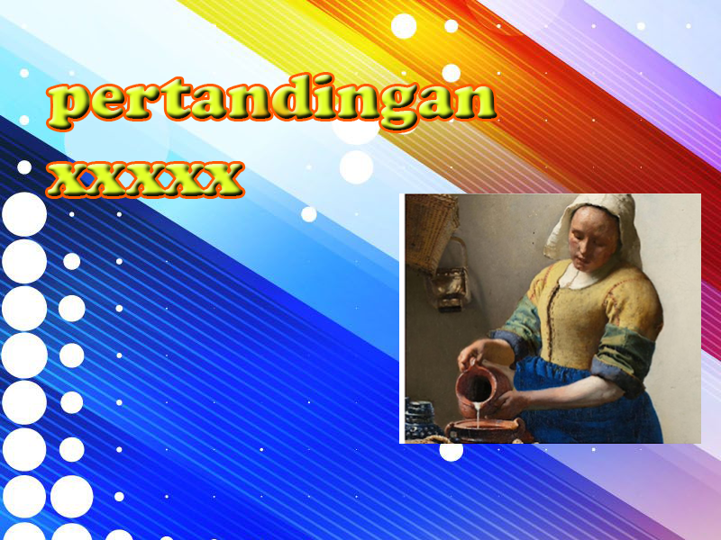

**Tukar koding**

Peserta_update

Peserta_senarai – tmbah id urusetia

Hakim_insert- tmbh koding

Penilaian_insert

Peserta_insert = tmbh koding

Urusetia_insert

